Synopsis of Lab Project

Title: Movie Recommendation with Facial Recognition

Objective:- People often get frustrated thinking about a movie and 80% of time people watching movie are happy but they get confuse on what to watch

Procedure-

Step 1- Running the facial expression recogniser’s code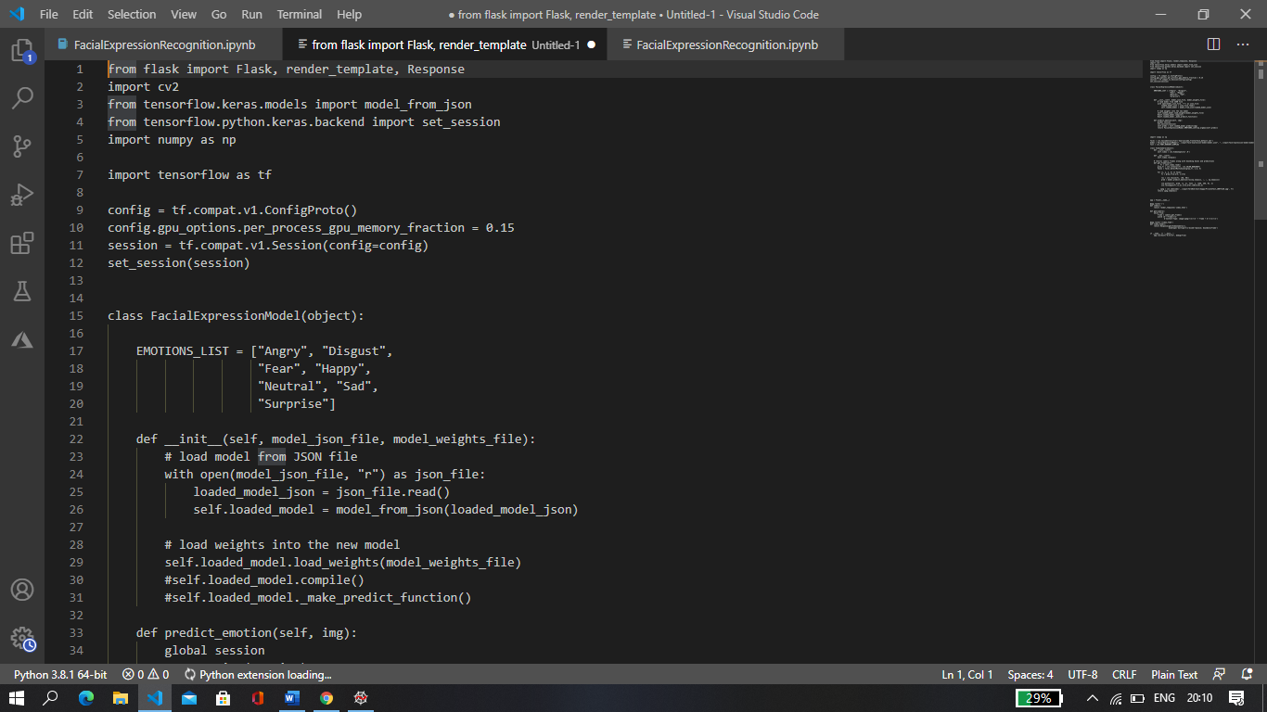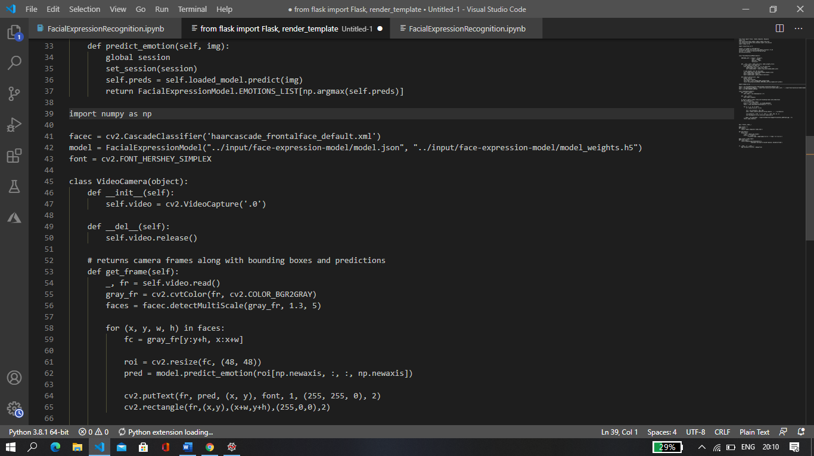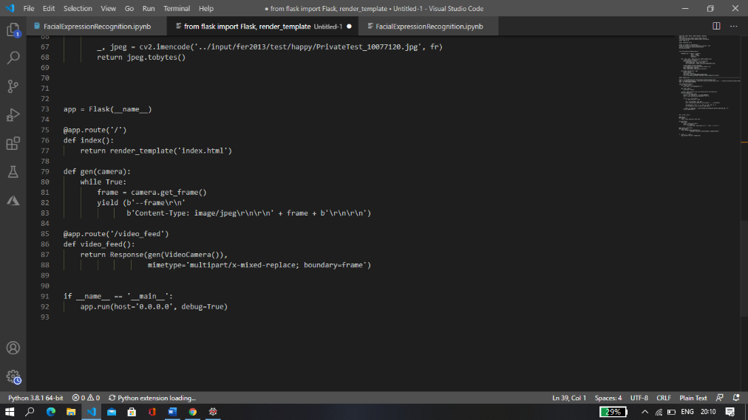

Information- In this code we are using 3 libraries

Open cv – To use camera and image recognition feature

Tensorflow-Keras- Keras is a deep learning API which is used with tensorflow

Flask- It is a library to call web application setup while using camera

haarcascade_frontalface_default.xml – This file helps to read basic features of face that are eyes, nose, lips and expressions

Hence after running this code a camera will pop up, it will recognise your facial expression and define the expression as one of the following (Happy, sad, disgust, anger, fear, surprise and )

Step 2- Running the Movie Recommendation code

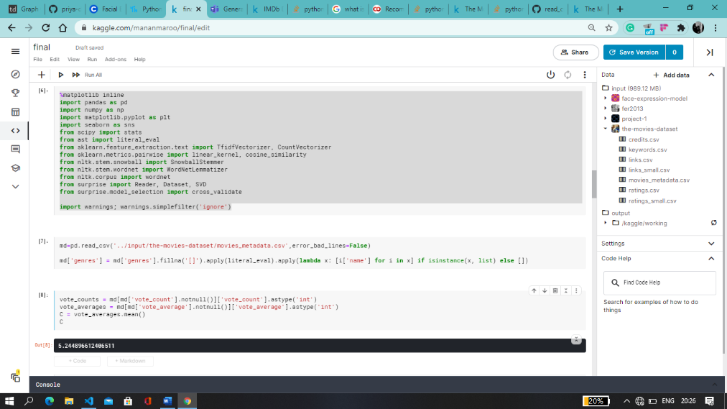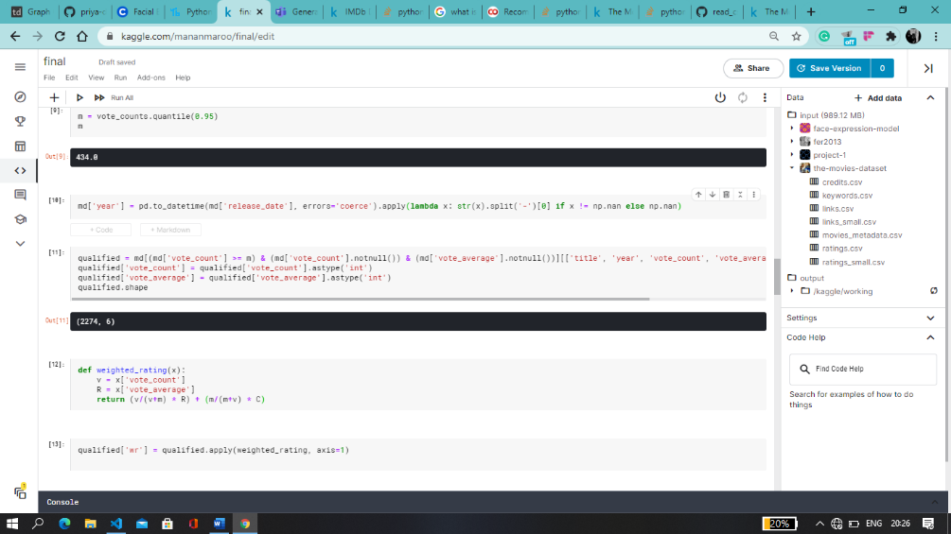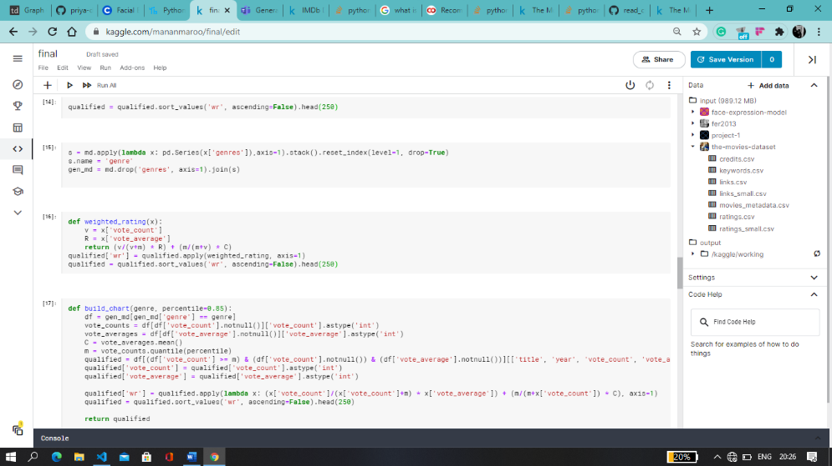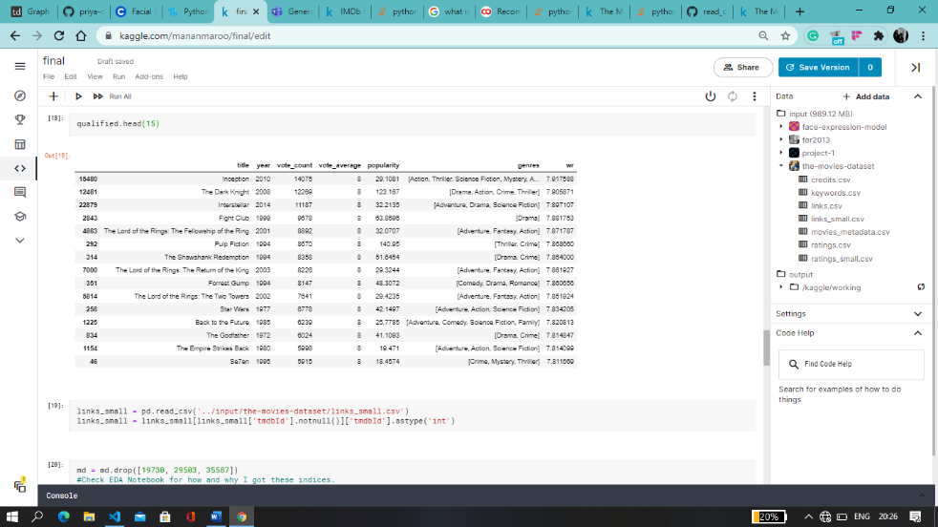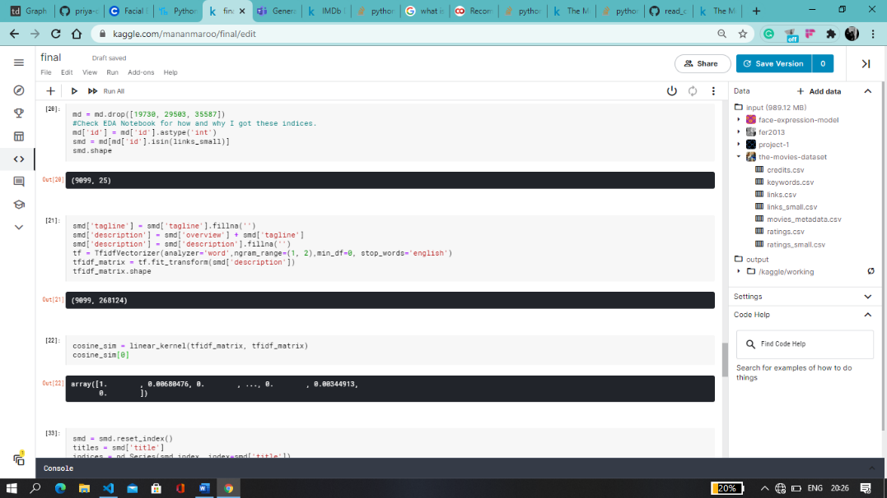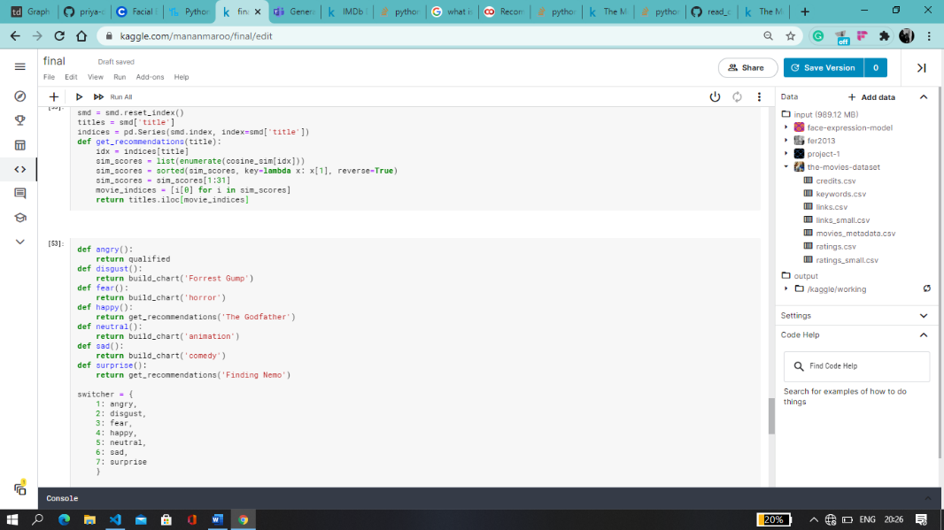

Information –

We are using Kaggle as the platform as it has a big set of dataset available

Dataset used- <https://www.kaggle.com/rounakbanik/the-movies-dataset>

By using Pandas we classify and break the data and create two functions

A] Build_chart- This helps in finding movie or recommending movies from a particular genre

For eg- build_chart(‘Romance’)

B] Get_recommendations- This function helps in giving the list of movies similar to the movie you wrote. Eg- get_recommendations(‘Finding Nemo’)

Step 3- Combining Both the codes

After getting the emotions using facial recognition we specify a genre or a movie to the emotions

As I used

def angry():

return build_chart(‘drama’)

def disgust():

return build_chart('Forrest Gump')

def fear():

return build_chart('horror')

def happy():

return get_recommendations('The Godfather')

def neutral():

return build_chart('animation')

def sad():

return build_chart('comedy')

def surprise():

return get_recommendations('Finding Nemo')

switcher = {

1: angry,

2: disgust,

3: fear,

4: happy,

5: neutral,

6: sad,

7: surprise

}

So this code will run the emotion with the switcher and return the specified return value and hence recommend a movie for you to watch

Github Link- <https://github.com/mananmaroo/Movie-Recommendation-using-Facial-ExpressionReco>

*Might have a bug or two*